BEAR – Zaniri’s Fire Bear
Sire: Casey - FC Firemark’s Rackem and Stackem Casey
Dam: Stormy – Zaniri’s Storm Warning at Ravengold MH

Bear is a wonderful competitive Field Trial golden. He had 16 Derby points and was on the Derby list. He has 2 Qualifying wins in Canada and 2 Qualifying wins in the US, which means he will be running in the Open and Amateur stakes from here on out and he is not yet 3 years old! He is hard driving, focused, intelligent, athletic, with great eyes and spatial orientation, and a great work ethic. He is a handsome, dark red golden with a lovely head and wonderful conformation.

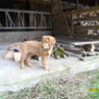
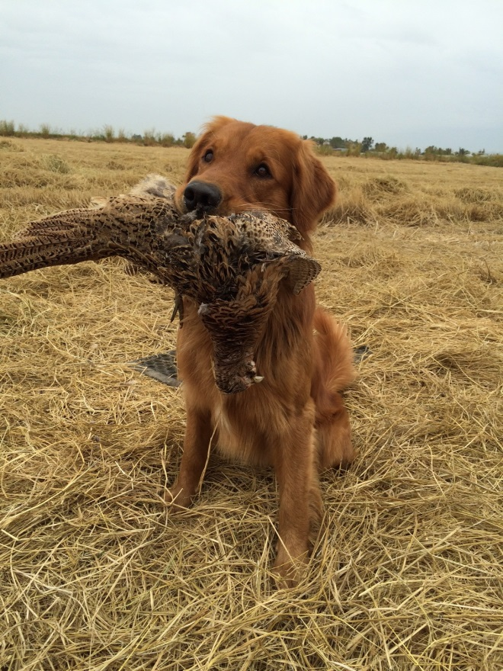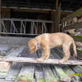
Bear is being handled jointly by Mark Akkola and Bev Tecklenborg. Mark has been in the field trial game for over 40 years and has always wanted to see a Golden compete with the black dogs. He is very high on Bear’s potential and what he could achieve.

Bev and Jo Tecklenborg got Bear for a pet but soon found that he needed a job! Bev worked with Joanne Kinney who brought her into the hunt test/field trial game. As Bear’s breeder, Mark also worked with Bev and saw Bear’s potential.

EMMA – Zaniri’s Justa New Day
Sire: Am Ch Amigold On A Wing N A Prayer CD MH WCX VCX DDHF OS*** x OTCH Dam: Zaniri Scenter of the Universe Am Can MH WCX TD Am CD, Can CH

Emma is a good marker, strong in water, and highly trainable, but her biggest asset is her outstanding Golden temperament. She is a beautiful, typey bitch, with solid bone and a great head. She won her Can Bred class at the GRCof BC Specialty in summer 2009. Judge's critique (Mr. Carl Leipmann USA) - "This dog is lovely going around. She has good proper reach and ard drive in the rear. The topline is nice and level." Colleen showed Emma to 8 points for her Can CH, she was then finished to her Championship by Shannon Scheer with a Best of Opp Sex.

Her previous pups have been absolutely loved and adored by their people. We believe that Bear will add a lot of drive to these puppies and we expect them to be highly trainable show, obedience, and hunt test competitors.

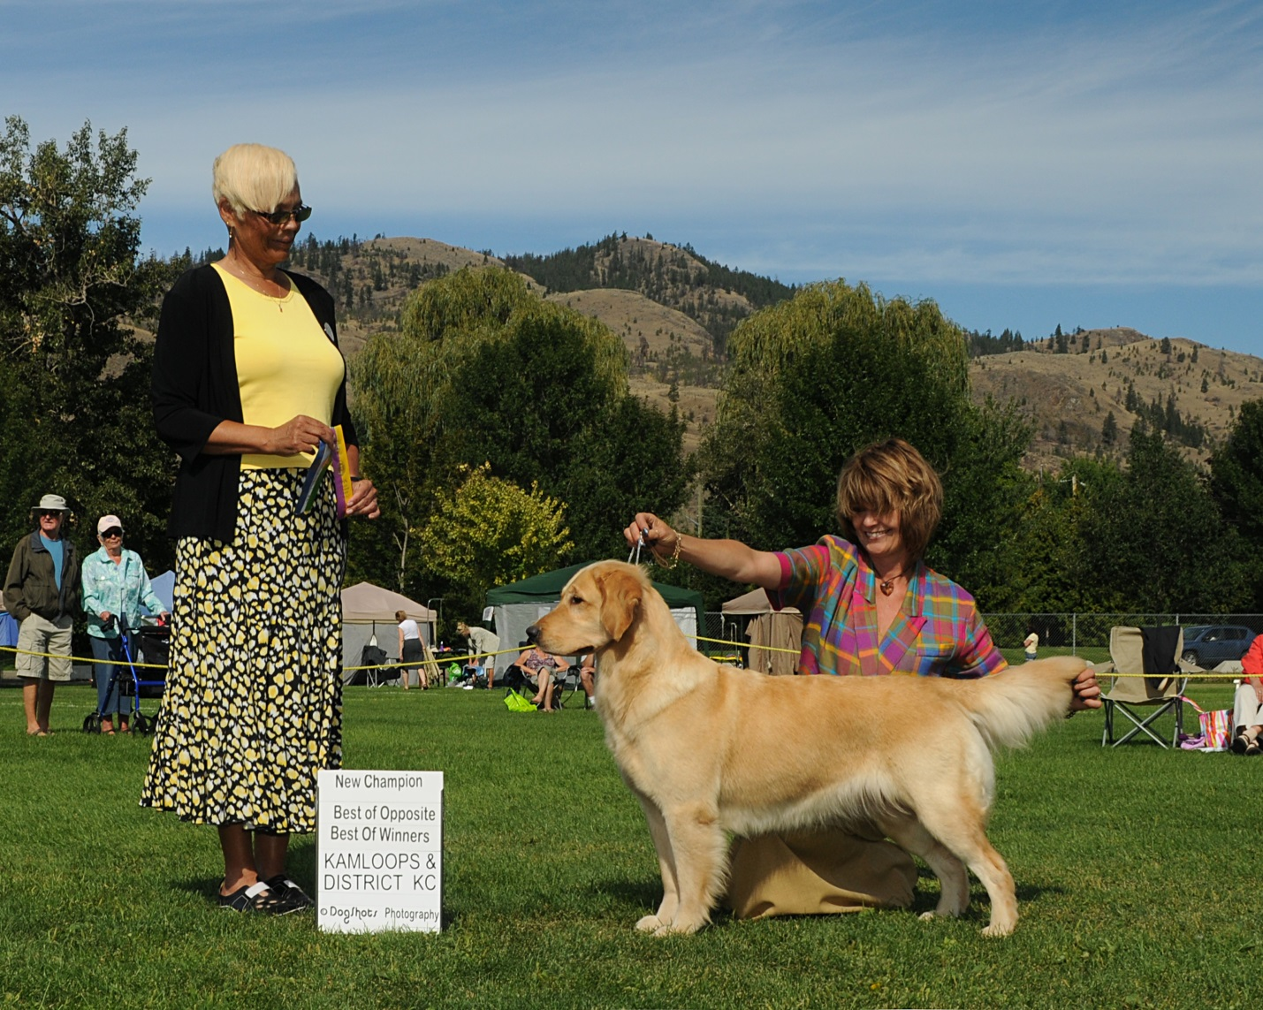

Pups are available for $1500.00 American. At the time the pregnancy is confirmed I will begin accepting deposits of $400.00 to reserve a pup. Of course this is also dependent on the amount of males and females that are born, and if the split means there is not a pup for you, I will return your deposit. Competition/working homes are sometimes given preference in placing pups, although a pet home where the pup will be loved and given a wonderful life is not discounted out of hand.
We expect this litter will produce outstanding performance dogs for hunt tests, obedience or any venue, that are highly trainable, good looking and most of all healthy and easy to live with as companions. My lifelong goal has been to breed Golden’s who can run competitively in field trials as well as compete in the show ring. Our goal in breeding is to focus on bettering the breed for the long term. Where some litters are focused more on increasing field or working traits (more suited for field trial, hunt test, agility or obedience), other litters are stronger on show side (suited for Can CH MH UD or anything you chose).

* Competition puppies normally reserved well in advance although cancellations do sometimes

Puppies are raised in the house; bio-stimulation, lots of toys/birds in whelping box, duck trailing, pigeons, jungle gyms on varying surfaces and lots of walks on our 2 acres, through trees and landscaping, to build intelligence and confidence. Temperament testing and outside conformation evaluation, along with standard worming, first vaccination, dew claws on according to latest science and a written contract.

